What is Machine Learning and Why it is Important?

1. Introduction to Machine Learning & Definitions

Machine learning is a branch of artificial intelligence. It involves the use of algorithms, which are mathematical models that predict or produce outcomes based on trained data, without requiring explicit programming. This concept is analogous to how humans think or perform tasks based on their experiences.

ML employs computer science and statistics to create predictive models and perform tasks such as image, text, audio, and video recognition. Supervised, unsupervised, and reinforcement learning are distinct methods within machine learning. It is a self-learning model or system that predicts or refines outcomes based on experiences and historical data.

1. What is the need for Machine Learning?

Data scientists primarily rely on machine learning (ML) as a fundamental tool for data analysis, extraction from historical data, and more. ML finds applications across various sectors, including business, healthcare, stock markets, social media, gaming, and beyond. The field of ML is constantly evolving, leading to an increasing demand for ML expertise. This demand stems from the necessity to make better decisions and enable smart real-time actions based on historical data.

ML is utilized to comprehend vast amounts of data, discover patterns, and make real-time decisions. For a human, it's challenging to fully grasp all the details within large data sets on their own. Machine learning serves as a sort of assistant that enhances the intelligence of computers by learning from the information in their surroundings.

1. Different Terminologies:

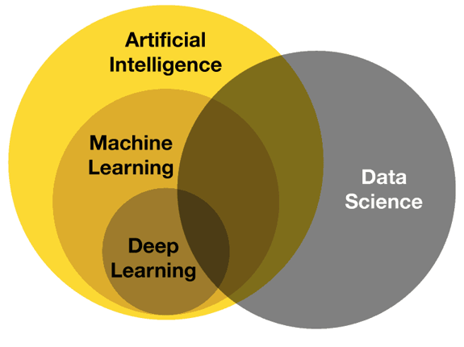

[[Figure](https://www.google.com/url?sa=i&url=http%3A%2F%2Favaricelaboratories.in%2Fperuse.aspx%3Fcname%3Ddifference%2Bbetween%2Bai%2Band%2Bmachine%2Blearning%2Band%2Bdata%2Bscience%26cid%3D23&psig=AOvVaw1EQIu3qjtGgNDQLH0phIGC&ust=1692524182384000&source=images&cd=vfe&opi=89978449&ved=0CBAQjRxqFwoTCMDlxIe26IADFQAAAAAdAAAAABBA) Source: Reference [2]](https://www.google.com/url?sa=i&url=https%3A%2F%2Fwww.deviq.io%2Finsights%2Fartificial-intelligence-vs-machine-learning-vs-data-science&psig=AOvVaw3lBDlWdN71S2DoGV-47sB3&ust=1692631004000000&source=images&cd=vfe&opi=89978449&ved=0CBAQjRxqFwoTCJCTgf_D64ADFQAAAAAdAAAAABAg)

#### **Artificial Intelligence:**

Artificial intelligence (AI) is a technology that aims to create software capable of simulating human-like thinking processes. AI develops algorithms that efficiently solve a wide range of problems and find applications in diverse domains such as gaming, speech recognition, language translation, and more. It's a fascinating field that aims to create machines that can think and act intelligently, opening possibilities for solving complex problems and making our technology more capable and helpful.

#### **Machine Learning:**

Machine learning (ML) is a branch of Artificial Intelligence (AI). It involves the development of algorithms rooted in mathematical statistics, which yield outcomes and enable real-time decision-making based on historical data and experiences.

ML mirrors the way humans think and make decisions, drawing parallels to how individuals shape their lives based on past encounters. ML finds applications in various fields such as image, audio, video, text recognition, etc.

#### **Deep Learning:**

#### Deep learning represents a specialized subfield within machine learning, centered around artificial neural networks. This advanced algorithmic approach operates on massive datasets, delivering outcomes with a capacity for intricate pattern recognition. Deep learning's architecture and functions are akin to the neural networks found in the human brain. It excels in solving complex problems that traditional machine learning and AI approaches struggle to address.

#### **Data Science:**

Data science is the science of transforming raw data into meaningful insights and actionable knowledge. It encompasses the entire data lifecycle, from the collection and preprocessing to analysis and interpretation. Data scientists harness their expertise in diverse tools and technologies to extract valuable information from large datasets, leading to informed decisions across numerous sectors, including healthcare, business, finance, and more.

1. Applications of Machine Learning

**Image and Video Analysis:**

Image and video analysis in machine learning refers to the process of teaching computers to understand and interpret visual content like pictures and videos. By using special algorithms and techniques, machines can recognize objects, people, scenes, and even text within these visual materials. For example, when you upload a photo to a social media platform, the platform's machine-learning algorithms can automatically suggest tags for people in the image.

**Natural Language Processing (NLP):**

In Natural Language Processing (NLP), text is analyzed using specialized artificial intelligence algorithms within the realm of machine learning. These algorithms focus on understanding the content of documents, which can range from social media comments and online reviews to survey responses, financial records, medical reports, legal documents, and regulatory information. Through NLP, these algorithms can predict outcomes and make informed decisions based on the text they've examined.

**Healthcare:**

In healthcare, machine learning plays a crucial role in diagnosing diseases.ML has the potential to improve diagnostic accuracy, enhance patient care, streamline operations, and lead to more proactive and personalized medical practices. It can accurately identify conditions like skin diseases, classify breast cancer, detect heart issues, and more, achieving accuracy rates of up to 90%. Machine learning isn't limited to human diseases alone; it's also used to diagnose diseases of plants.

**Finance:**

In the field of finance, machine learning (ML) serves various purposes including fraud detection, risk management, process automation, data analytics, customer support, and algorithmic trading. Financial institutions deal with substantial amounts of data, which they need to organize effectively. This organized data forms the foundation for making informed decisions and predicting the actual state of their business.

**Manufacturing and Industry:**

In the manufacturing and industrial sectors, there's a need to predict whether a company will make a profit or face losses. Machine learning plays a role in achieving these goals. ML also enables better supply chain management, helps in maintaining product quality, enhances employee safety measures, and even leads to improved product designs.

## References:

1. <https://business.wfu.edu/masters-in-business-analytics-online/articles/machine-learning-job-roles/>
2. <https://www.deviq.io/insights/artificial-intelligence-vs-machine-learning-vs-data-science>
3. <https://www.javatpoint.com/machine-learning>